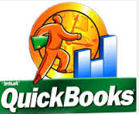

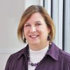

STLREIA QuickBooks Class Instructor Bio

Laura Spandrio, MBA, has over 20 years accounting experience in the real estate, construction, manufacturing, and service industries. She holds a Bachelor’s degree in Accounting and a Masters of Business Administration degree from Colorado State University.
In addition, she is the Co-Recipient of Robert Kiyosaki’s (Rich Dad, Poor Dad) Hall of Fame Inductee. This was an award for extraordinary accomplishments in completing various types of real estate transactions.
Secure Accounting Solution's special niche is accounting systems for Real Estate Professionals, as there are many unique and special accounting requirements in this industry. Laura knows the real estate business well and can help your business grow through accurate, up to date accounting systems needed to make informed business decisions.
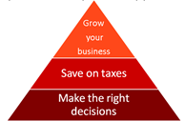
Laura is passionate about assisting small and mid-sized businesses clean up and maintain their accounting systems. She also loves to show business owners how to quickly and efficiently keep up on their accounting functions so they can be more informed as to the financial health of their business.
Decision making is a vital component of small business success. Decisions that are based on a foundation of knowledge and sound reasoning can lead the company into long term prosperity.
Timely and accurate financial reporting is critical for a business success. This is key to assuring your decision is based on correct information. Often, these decisions must be made quickly when opportunities arise.

Good numbers equals good decisions,

which equals business growth!!

EXPAND YOUR KNOWLEDGE, SAVE ON TAXES and BULLET PROOF YORU BUSINESS! Bring your laptop loaded with Quick Books and join your fellow STLREIA members on December 10th, 2016 for this valuable training session.
DON’T WAIT. GO TO stlreia.com and sign up NOW! The class is limited to 25 participants.

